**FPT ACADEMY INTERNATIONAL FPT – APTECH COMPUTER EDUCATION**



**Book Tour Travel Hotel**

|  |  |  |
| --- | --- | --- |
| **Team:** | **T1.2209.E0** | |
| **Serial No.** | **Student Name** | **Enrollment Number** |
| **1** | **Lê Thanh Thiên** | **Student1420696** |
| **2** | **Nguyễn Ngọc Thanh Chương** | **Student1416070** |
| **3** | **Quảng Đại Vi** | **Student1420703** |

Contents

1. **Definition of the Problem** 3
2. **Requirement Analysis** 3
3. **Design Phase** 3
4. **Architecture of Website** 4
5. **Evaluation/Testing** 4
6. **Project Tracking and Monitoring Activities** 5
7. **Documentation Section** 6
8. **Source Code** 17

# INTRODUCTION

Welcome to Book Tour Travel - the place where you can embark on limitless cultural adventures through the pages of captivating books! If you're seeking unique and valuable travel experiences, join us and immerse yourself in journeys where every page is a splendid canvas of culture and history.

Key features of our website:

* Discover the New: Enjoy exploring unique destinations through the pages of carefully selected books that transport you to different cultures and historical periods.
* Interactive Platform: Engage with fellow book and travel enthusiasts. Share your thoughts, recommendations, and experiences, fostering a vibrant community of like-minded individuals.
* Curated Book Catalog: Browse our extensive catalog of books categorized by destination, theme, or historical era. Find the perfect read to inspire your next adventure.
* Traveler Reviews: Read firsthand accounts from fellow travelers who have embarked on literary journeys. Get recommendations and tips for enhancing your own book-inspired travels.

# PROBLEM DEFINITION

The Book Tour Travel website aims to provide a platform for readers and travel enthusiasts to explore and engage in unique cultural adventures through literature. The website needs to ensure that the travel experiences through books are authentic, unique, and valuable for users. The challenges include:

* Attracting and Retaining Readers and Travelers: Creating compelling content to attract readers and travel enthusiasts. Building an interactive platform where users can share experiences, book reviews, and travel suggestions.
* Competing with Other Travel Websites and Markets: Facing competition from other travel websites and markets, the website needs to offer uniqueness and value to attract and retain customers.
* Handling Transactions and Customer Service Issues: Efficiently managing secure payment processing, reliable shipping, and delivery. Simultaneously, addressing customer service issues and resolving disputes effectively.
* Building Trust and Reputation: Ensuring that all information on the website is authentic and trustworthy. Establishing a reputable presence within the reader and traveler community.

Based on the project analysis, to meet user expectations effectively, we propose the following solutions:

## **FROM THE VIEW POINT OF VISITORS**

### **What does a visitor need at an book tour travel site?**

* Detailed Descriptions:
* Provide detailed information about each travel tour, including destinations, itineraries, included services, and pricing.
* Ensure clear and understandable descriptions to give customers an overview of the travel experience.
* High-Quality Image Gallery:
* Integrate a high-quality and zoomable image gallery showcasing the highlights of each tour, including destinations, accommodations, and activities.
* Visual content should be compelling and accurately represent the tour experience.
* Secure and Easy Payment System:
* Implement a secure and user-friendly payment system that accepts various payment methods and currencies.
* Provide invoices and receipts for transparency and record-keeping.
* Reliable and Transparent Booking Process:
* Ensure a reliable and transparent booking process, offering details on terms, conditions, and any potential additional costs.
* Include a tracking system for customers to monitor the status of their bookings.
* User-Friendly Website Design:
* Design a user-friendly and responsive website that allows visitors to easily browse, search, filter, and compare different tour options.
* Prioritize a seamless and intuitive navigation experience.
* Customer Support:
* Establish a customer service and support team available 24/7 through various channels such as phone, email, or chat.
* Address customer inquiries, concerns, and provide assistance throughout the booking process.
* Feedback and Rating System:
* Implement a feedback and rating system where customers can leave reviews and ratings for tours.
* Enable potential customers to make informed decisions based on the experiences of others.

## **FROM THE VIEW POINT OF THE ADMINISTRATOR**

User management: This function allows the site administrator to create, edit, delete, and manage user accounts, roles, and permissions. The site administrator can also monitor user activity, feedback, and ratings, as well as ban or suspend users who violate the site rules or policies.

Auction management: This function allows the site administrator to create, edit, delete, and manage auctions, lots, categories, and subcategories. The site administrator can also set the auction type (such as English, Dutch, reverse, etc.), duration, starting price, reserve price, bid increment, and other parameters. The site administrator can also monitor the bidding process, approve or reject bids, and close or cancel auctions.

Payment management: This function allows the site administrator to process and manage payments from buyers and sellers. The site administrator can also set the payment methods (such as credit card, PayPal, bank transfer, etc.), fees, commissions, taxes, and other charges. The site administrator can also issue invoices, receipts, refunds, and disputes.

Inventory management: This function allows the site administrator to track and manage the inventory of antiques on the site. The site administrator can also verify the authenticity, condition, and provenance of the antiques, as well as upload photos, videos, descriptions, and other details. The site administrator can also assign barcodes or QR codes to the antiques for easy identification and tracking.

Shipping management: This function allows the site administrator to arrange and manage the shipping of antiques from sellers to buyers. The site administrator can also set the shipping methods (such as courier, postal service, etc.), rates, insurance, and tracking. The site administrator can also handle shipping issues such as delays, damages, or losses.

Analytics and reporting: This function allows the site administrator to generate and view various reports and statistics on the site performance, user behavior, auction activity, revenue, expenses, and other metrics. The site administrator can also use analytics tools (such as Google Analytics) to optimize the site design, layout, content, SEO (search engine optimization), marketing campaigns (such as email newsletters), and other aspects.

# CUSTOMER'S REQUIREMENTS SPECIFICATIONS (CRS)

## **CLIENT: Online tour booking**

## **BUSINESS/PROJECT OBJECTIVE:**

An online tour booking website is a platform that allows users to search, book, and manage various travel experiences through an online booking process. Users can explore multiple categories and destinations, search by keywords, filters, or specific locations, and participate in different types of tours, including group tours, private tours, etc. Users can make tour reservations and receive confirmations directly on the website.

## **INPUT TO THE SYSTEM:**

### **What an online tour booking website needs to provide for the administrator:**

### **User Management::**

* **Registration and Login**: Enable users to create and access personal accounts, manage personal information, preferences, payment methods, reviews, and booking history.
* **Tour Listing and Browsing**: Display and search various tours, destinations, categories, and subcategories on the website.
* Provide filtering and sorting options based on keywords, location, price range, tour type, and other criteria.
* **Tour Participation and Booking**: Allow users to join tours and make reservations. Display information on tour prices, remaining slots, time left, and booking history.
* **Tour Creation and Management**: Allow tour organizers to create and manage their own tours.
* Integrate features for uploading photos and tour descriptions, as well as setting tour types, duration, starting prices, etc.
* **Payment Processing and Security**: Support secure and convenient payment methods, such as credit cards, PayPal, bank transfers, etc. Display transaction history and invoices for users.
* **Customer Support and Feedback**: Provide communication channels for users to contact the support team for inquiries or issues. Allow users to leave feedback and ratings for the tours they have participated in.

### **What customers need to provide:**

* **Personal Information**: Including name, email address, phone number, and password to create and access their accounts on the website.
* **Payment Information**: Including credit card number, expiration date, security code, billing address, and other necessary details for secure online payments.
* **Booking Information**: Including details such as the desired tour, dates, number of participants, and any other preferences.

## OUTPUT FROM THE SYSTEM

### For a travel booking website, administrators will have the ability to:

* Manage user accounts and tour listings.
* Monitor tour booking activities and transactions.
* Verify the authenticity and quality of listed tours.
* Resolve disputes and address issues as they arise.
* Generate comprehensive reports and analytics to assess website performance.

### For visitors exploring the travel booking website, they will have the ability to:

* Explore a diverse range of tours, including group tours, private tours, and more.
* Track their favorite categories and receive updates on related tours.
* Discover new tours and upcoming travel experiences regularly.
* Read articles providing in-depth information about completed destinations and upcoming tours.
* Gain knowledge about history and culture through travel experiences from various countries around the world.
* View featured tours and details about upcoming travel experiences through catalogs and images.
* Register for free and use features such as tour booking alerts, wish lists, and saved searches.
* Watch live streaming programs online at any time, from any location, and on any device.

### As for customers/travelers, they will have the ability to:

* Sign up or log in to access the website's features.
* Create and manage their personal profile and preferences, including budget settings, favorite tour types, payment methods, and travel preferences.
* Verify their identity easily through electronic Know Your Customer (eKYC) or ID documents.
* Quickly update payment and booking information.
* Follow and actively participate in booking tours during ongoing travel experiences.

# REVIEW 1

## TASK SHEET REVIEW 1

|  |  |  |  |
| --- | --- | --- | --- |
| **Description** | **Begin Date** | **TeamMate Name** | **Notes** |
| Acknowledgement | 29/12/2023 | Lê Thanh Thiên |  |
| Problem Statement | Nguyễn Ngọc Thanh Chương |  |
| Requirement Specification | Lê Thanh Thiên |  |
| Function Diagram of Visitor | Lê Thanh Thiên |  |
| Function Diagram of Administrator | Lê Thanh Thiên |  |
| Task Sheet | Nguyễn Ngọc Thanh Chương |  |

|  |  |
| --- | --- |
| **Date:** | |
| Signature of Instructor:  **MS. LE MONG THUY** | Signature of Team Leader:  **Le Thanh Thien** |

### Table design

### 

|  |  |  |  |  |  |  |
| --- | --- | --- | --- | --- | --- | --- |
| **1 Tour** | | | | | | |
| **Colum** | **Type** | **Property** | **Null** | **Default** | **Extra** | **Atribute** |
| id | bigint | UNSIGNED | No | None | auto_inc rement |  |
| Tour_code | Varchar |  | Yes | None |  |  |
| title | Varchar |  | No | None |  |  |
| slug | Varchar |  | No | None |  |  |
| introduce | text |  | Yes | None |  |  |
| schedule | text |  | Yes | None |  |  |
| status | text |  | Yes | None |  |  |
| Duration | int |  | Yes | None |  |  |
| Place_id | bigint | UNSIGNED | No | None |  |  |
| Category_id | bigint | UNSIGNED | Yes | Null |  |  |
| Vehicle_id | bigint | UNSIGNED | No | None |  |  |
| prominent | tinyint |  | Yes | None |  |  |
| created_at | timestamp |  | Yes | NULL |  |  |
| updated_at | timestamp |  | Yes | NULL |  |  |

### 

|  |  |  |  |  |  |  |
| --- | --- | --- | --- | --- | --- | --- |
| **2 Tours time** | | | | | | |
| **Colum** | **Type** | **Property** | **Null** | **Default** | **Extra** | **Atribute** |
| id | bigint | UNSIGNED | No | None | auto_inc rement |  |
| Time_code | varchar |  | No | None |  |  |
| Tour_id | bigint | UNSIGNED | No | None |  |  |
| status | Varchar |  | No | None |  |  |
| Slots_remaning | int |  | No | None |  |  |
| Slots_booked | int |  | No | None |  |  |
| Price_adults | int | UNSIGNED | No | None |  |  |
| Price_children | int | UNSIGNED | No | None |  |  |
| date | date |  | No | None |  |  |
| created_at | timestamp |  | Yes | NULL |  |  |
| updated_at | text |  | Yes | NULL |  |  |

|  |  |  |  |  |  |  |
| --- | --- | --- | --- | --- | --- | --- |
| **3 Booking tour** | | | | | | |
| **Colum** | **Type** | **Property** | **Null** | **Default** | **Extra** | **Atribute** |
| id | bigint | UNSIGNED | No | None | auto_inc rement |  |
| Booking_code | varchar |  | No | None |  |  |
| Tour_id | bigint | UNSIGNED | No | None |  |  |
| tourTime_id | bigint | UNSIGNED | No | None |  |  |
| adults | int |  | No | None |  |  |
| children | int |  | No | None |  |  |
| Total_price | Double(8,2) |  | No | None |  |  |
| User_id | bigint | UNSIGNED | No | None |  |  |
| Payment_id | bigint | UNSIGNED | No | None |  |  |
| Status_payment | enum | UNSIGNED | No | None |  |  |
| Status_booking | enum |  | No | None |  |  |
| created_at | timestamp |  | Yes | NULL |  |  |
| updated_at | timestamp |  | Yes | NULL |  |  |

|  |  |  |  |  |  |  |
| --- | --- | --- | --- | --- | --- | --- |
| **4 Slot_tour** | | | | | | |
| **Colum** | **Type** | **Property** | **Null** | **Default** | **Extra** | **Atribute** |
| id | bigint | UNSIGNED | No | None | auto_inc rement |  |
| Name | varchar |  | Yes | None |  |  |
| Email | varchar | UNSIGNED | Yes | NULL |  |  |
| Phone | varchar | UNSIGNED | Yes | NULL |  |  |
| Passport | varchar | UNSIGNED | Yes | NULL |  |  |
| Nationality_id | bigint |  | Yes | NULL |  |  |
| Booking_tour_id | bigint |  | No | NULL |  |  |
| type | enum |  | No | None |  |  |
| created_at | timestamp |  | Yes | NULL |  |  |
| updated_at | timestamp |  | Yes | NULL |  |  |

|  |  |  |  |  |  |  |
| --- | --- | --- | --- | --- | --- | --- |
| **5 payment** | | | | | | |
| **Colum** | **Type** | **Property** | **Null** | **Default** | **Extra** | **Atribute** |
| id | bigint | UNSIGNED | No | None | auto_inc rement |  |
| Title | varchar |  | No | None |  |  |
| description | varchar |  | No | None |  |  |
| created_at | timestamp |  | Yes | NULL |  |  |
| updated_at | timestamp |  | Yes | NULL |  |  |

|  |  |  |  |  |  |  |
| --- | --- | --- | --- | --- | --- | --- |
| **6 cart_tour** | | | | | | |
| **Colum** | **Type** | **Property** | **Null** | **Default** | **Extra** | **Atribute** |
| id | bigint | UNSIGNED | No | None | auto_inc rement |  |
| Tour_id | bigint | UNSIGNED | No | None |  |  |
| User_id | bigint | UNSIGNED | No | None |  |  |
| Tour_time_id | varchar(255) | UNSIGNED | No | None |  |  |
| adults | int |  | No | None |  |  |
| children | int |  | No | None |  |  |
| total | int |  | No | None |  |  |
| created_at | timestamp |  | Yes | NULL |  |  |
| updated_at | timestamp |  | Yes | NULL |  |  |

|  |  |  |  |  |  |  |
| --- | --- | --- | --- | --- | --- | --- |
| **7 tour_path** | | | | | | |
| **Colum** | **Type** | **Property** | **Null** | **Default** | **Extra** | **Atribute** |
| id | bigint | UNSIGNED | No | None | auto_inc rement |  |
| path | varchar |  | No | None |  |  |
| Tour_id | bigint | UNSIGNED | No | None |  |  |
| created_at | timestamp |  | Yes | NULL |  |  |
| updated_at | timestamp |  | Yes | NULL |  |  |

|  |  |  |  |  |  |  |
| --- | --- | --- | --- | --- | --- | --- |
| **8 category** | | | | | | |
| **Colum** | **Type** | **Property** | **Null** | **Default** | **Extra** | **Atribute** |
| id | bigint | UNSIGNED | No | None | auto_inc rement |  |
| name | Varchar |  | No | None |  |  |
| created_at | timestamp |  | Yes | NULL |  |  |
| updated_at | timestamp |  | Yes | NULL |  |  |

|  |  |  |  |  |  |  |
| --- | --- | --- | --- | --- | --- | --- |
| **9 vehicles** | | | | | | |
| **Colum** | **Type** | **Property** | **Null** | **Default** | **Extra** | **Atribute** |
| id | bigint | UNSIGNED | No | None | auto_inc rement |  |
| name | varchar(255) |  | No | None |  |  |
| created_at | timestamp |  | Yes | NULL |  |  |
| updated_at | timestamp |  | Yes | NULL |  |  |

|  |  |  |  |  |  |  |
| --- | --- | --- | --- | --- | --- | --- |
| **10 nationality** | | | | | | |
| **Colum** | **Type** | **Property** | **Null** | **Default** | **Extra** | **Atribute** |
| id | bigint | UNSIGNED | No | None | auto_inc rement |  |
| name | Varchar |  | No | None |  |  |
| created_at | timestamp |  | Yes | NULL |  |  |
| updated_at | timestamp |  | Yes | NULL |  |  |

|  |  |  |  |  |  |  |
| --- | --- | --- | --- | --- | --- | --- |
| **11 users** | | | | | | |
| **Colum** | **Type** | **Property** | **Null** | **Default** | **Extra** | **Atribute** |
| id | int | UNSIGNED | No | None | auto_inc rement |  |
| name | varchar(255) |  | No | None |  |  |
| email | Varchar |  | No | None |  |  |
| phone | Varchar |  | Yes | NULL |  |  |
| Email_verified_at | timestamp |  | Yes | NULL |  |  |
| password | Varchar |  | No | None |  |  |
| Remember_token | Varchar |  | Yes | NULL |  |  |
| avatar | Varchar |  | Yes | NULL |  |  |
| wallet | int |  | Yes | NULL |  |  |
| Department_id | bigint | UNSIGNED | No | None |  |  |
| Status_id | bigint | UNSIGNED | No | None |  |  |
| created_at | timestamp |  | Yes | NULL |  |  |
| updated_at | timestamp |  | Yes | NULL |  |  |

|  |  |  |  |  |  |  |
| --- | --- | --- | --- | --- | --- | --- |
| **12 user_status** | | | | | | |
| **Colum** | **Type** | **Property** | **Null** | **Default** | **Extra** | **Atribute** |
| id | bigint | UNSIGNED | No | None |  |  |
| name | varchar(255) |  | No | None |  |  |
| created_at | timestamp |  | Yes | NULL |  |  |
| updated_at | timestamp |  | Yes | NULL |  |  |

|  |  |  |  |  |  |  |
| --- | --- | --- | --- | --- | --- | --- |
| **13 places** | | | | | | |
| **Colum** | **Type** | **Property** | **Null** | **Default** | **Extra** | **Atribute** |
| id | bigint | UNSIGNED | No | None | auto_inc rement |  |
| country | varchar(255) |  | No | None |  |  |
| slug | Varchar |  | No | None |  |  |
| Area_id | bigint | UNSIGNED | No | None |  |  |
| prominent | tinyint |  | No | None |  |  |
| image | Varchar |  | No | None |  |  |
| created_at | timestamp |  | Yes | NULL |  |  |
| updated_at | timestamp |  | Yes | NULL |  |  |

|  |  |  |  |  |  |  |
| --- | --- | --- | --- | --- | --- | --- |
| **14 area** | | | | | | |
| **Colum** | **Type** | **Property** | **Null** | **Default** | **Extra** | **Atribute** |
| id | bigint | UNSIGNED | Không |  | auto_inc rement |  |
| name | Varchar |  | Không |  |  |  |
| created_at | timestamp |  | Yes | NULL |  |  |
| updated_at | timestamp |  | Yes | NULL |  |  |

|  |  |  |  |  |  |  |
| --- | --- | --- | --- | --- | --- | --- |
| **15 departents** | | | | | | |
| **Colum** | **Type** | **Property** | **Null** | **Default** | **Extra** | **Atribute** |
| id | bigint | UNSIGNED | No | None | auto_inc rement |  |
| name | text |  | No | None |  |  |
| created_at | timestamp |  | Yes | NULL |  |  |
| updated_at | timestamp |  | Yes | NULL |  |  |

|  |  |  |  |  |  |  |
| --- | --- | --- | --- | --- | --- | --- |
| **16 booking_hotel** | | | | | | |
| **Colum** | **Type** | **Property** | **Null** | **Default** | **Extra** | **Atribute** |
| id | bigint | UNSIGNED | No | None | auto_inc rement |  |
| Room_type_id | bigint | UNSIGNED | No | None |  |  |
| Room_id | bigint | UNSIGNED | No | None |  |  |
| Hotel_id | bigint | UNSIGNED | No | None |  |  |
| name | Varchar |  | No | None |  |  |
| Phone | Varchar |  | No | None |  |  |
| email | Varchar |  | No | None |  |  |
| Start_date | Date |  | No | None |  |  |
| End_date | Date |  | No | None |  |  |
| price | Int |  | No | None |  |  |
| totalDays | int |  | No | None |  |  |
| User_id | bigint | UNSIGNED | No | None |  |  |
| Status_booking | enum |  | No | None |  |  |
| created_at | timestamp |  | Yes | NULL |  |  |
| updated_at | timestamp |  | Yes | NULL |  |  |

|  |  |  |  |  |  |  |
| --- | --- | --- | --- | --- | --- | --- |
| **17 rooms** | | | | | | |
| **Colum** | **Type** | **Property** | **Null** | **Default** | **Extra** | **Atribute** |
| id | bigint | UNSIGNED | No | None | auto_inc rement |  |
| Room_type_id | bigint | UNSIGNED | No | None |  |  |
| Status | enum |  | No | None |  |  |
| Number_of_Rooms | int |  | No | None |  |  |
| created_at | timestamp |  | Yes | NULL |  |  |
| updated_at | timestamp |  | Yes | NULL |  |  |

|  |  |  |  |  |  |  |
| --- | --- | --- | --- | --- | --- | --- |
| **18 hotels** | | | | | | |
| **Colum** | **Type** | **Property** | **Null** | **Default** | **Extra** | **Atribute** |
| id | bigint | UNSIGNED | No | None |  |  |
| title | Varchar |  | No | None |  |  |
| Slug | varchar(45) |  | No | None |  |  |
| address | Varchar |  | No | None |  |  |
| status | longtext |  | No | None |  |  |
| introduce | Text |  | No | None |  |  |
| Star_rating | tinyint | UNSIGNED | Yes | Null |  |  |
| Place_id | bigint | UNSIGNED | No | None |  |  |
| Checkin_time | time |  | No | None |  |  |
| Checkout_time | time |  | No | None |  |  |
| created_at | timestamp |  | Yes | Null |  |  |
| updated_at | timestamp |  | Yes | Null |  |  |

|  |  |  |  |  |  |  |
| --- | --- | --- | --- | --- | --- | --- |
| **19 room_type_amenitites** | | | | | | |
| **Colum** | **Type** | **Property** | **Null** | **Default** | **Extra** | **Atribute** |
| id | bigint | UNSIGNED | No | None | auto_inc rement |  |
| Room_type_id | bigint | UNSIGNED | No | None |  |  |
| Amenities_id | bigint | UNSIGNED | No | None |  |  |
| created_at | timestamp |  | Yes | NULL |  |  |
| updated_at | timestamp |  | Yes | NULL |  |  |

|  |  |  |  |  |  |  |
| --- | --- | --- | --- | --- | --- | --- |
| **20 amenitites** | | | | | | |
| **Colum** | **Type** | **Property** | **Null** | **Default** | **Extra** | **Atribute** |
| id | bigint | UNSIGNED | No | None | auto_inc rement |  |
| name | Varchar |  | No | None |  |  |
| created_at | timestamp |  | Yes | NULL |  |  |
| updated_at | timestamp |  | Yes | NULL |  |  |

|  |  |  |  |  |  |  |
| --- | --- | --- | --- | --- | --- | --- |
| **21 room_type** | | | | | | |
| **Colum** | **Type** | **Property** | **Null** | **Default** | **Extra** | **Atribute** |
| id | bigint | UNSIGNED | No | None | auto_inc rement |  |
| Hotel_id | bigint | UNSIGNED | No | None |  |  |
| name | Varchar |  | No | None |  |  |
| status | tenum |  | No | None |  |  |
| slug |  |  | No | None |  |  |
| image |  |  | No | None |  |  |
| Bed_type_id | bigint | UNSIGNED | No | None |  |  |
| price | int |  | No | None |  |  |
| Max_adults | int | UNSIGNED | No | None |  |  |
| Max_children | int | UNSIGNED | No | None |  |  |
| created_at | timestamp |  | Yes | NULL |  |  |
| updated_at | timestamp |  | Yes | NULL |  |  |

|  |  |  |  |  |  |  |
| --- | --- | --- | --- | --- | --- | --- |
| **22 hotel_paths** | | | | | | |
| **Colum** | **Type** | **Property** | **Null** | **Default** | **Extra** | **Atribute** |
| id | bigint | UNSIGNED | No | None | auto_inc rement |  |
| path | Varchar |  | No | None |  |  |
| Hotel_id | bigint | UNSIGNED | No | Noe |  |  |
| Yes | timestamp |  | Yes | NULL |  |  |
| updated_at | timestamp |  | Yes | NULL |  |  |

|  |  |  |  |  |  |  |
| --- | --- | --- | --- | --- | --- | --- |
| **23 bed_type** | | | | | | |
| **Colum** | **Type** | **Property** | **Null** | **Default** | **Extra** | **Atribute** |
| id | bigint | UNSIGNED | No | None | auto_inc rement |  |
| name | varchar |  | No | None |  |  |
| Yes | timestamp |  | Yes | NULL |  |  |
| updated_at | timestamp |  | Yes | NULL |  |  |

|  |  |  |  |  |  |  |
| --- | --- | --- | --- | --- | --- | --- |
| **24 categories_post** | | | | | | |
| **Colum** | **Type** | **Property** | **Null** | **Default** | **Extra** | **Atribute** |
| id | bigint | UNSIGNED | No | None | auto_inc rement |  |
| name | text |  | No | None |  |  |
| created_at | timestamp |  | Yes | NULL |  |  |
| updated_at | timestamp |  | Yes | NULL |  |  |

|  |  |  |  |  |  |  |  |
| --- | --- | --- | --- | --- | --- | --- | --- |
| **25 posts** | | | | | | | |
| **Colum** | **Type** | **Property** | **Null** | **Default** | **Extra** | **Atribute** |
| id | bigint | UNSIGNED | No | None | auto_inc rement |  |
| Title | Varchar |  | No | None |  |  |
| Slug | Varchar |  | No | None |  |  |
| Prominent | tinyint |  | No | None |  |  |
| Introduce | Text |  | No | None |  |  |
| image | Text |  | No | None |  |  |
| Categories_id | bigint | UNSIGNED | No | None |  |  |
| created_at | timestamp |  | Yes | NULL |  |  |
| updated_at | timestamp |  | Yes | NULL |  |  |

### **Relationship Diagram**

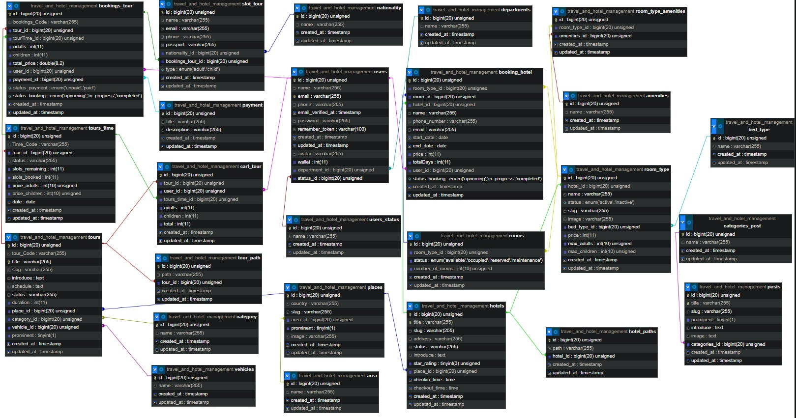

## **SITEMAP**

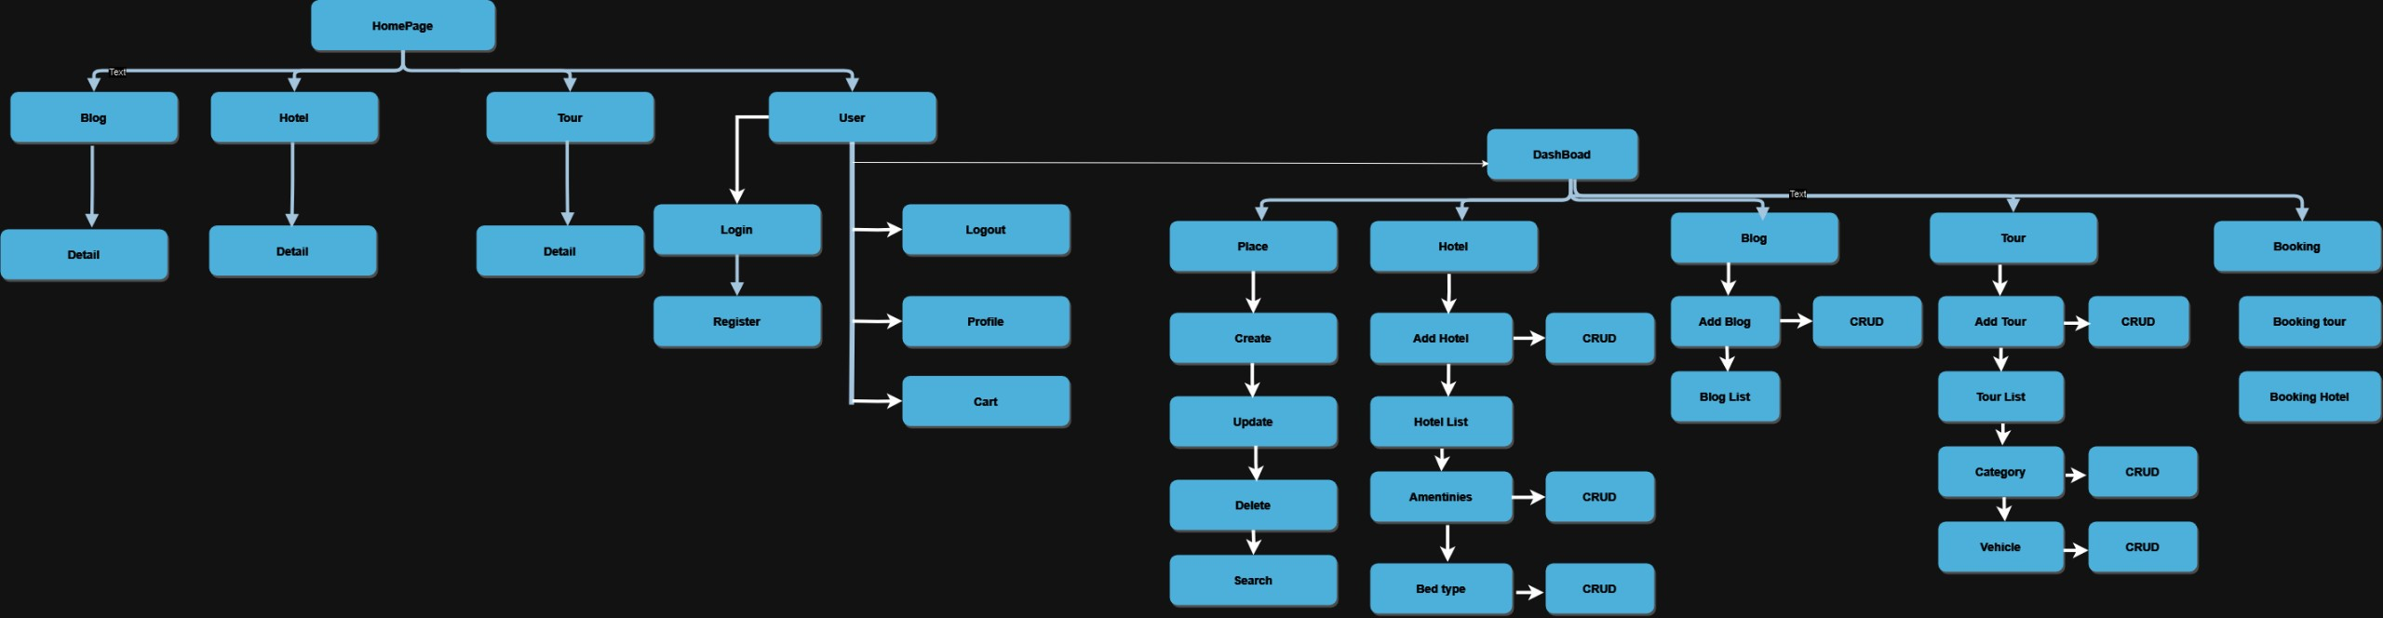

# REVIEW 2

## **TASK SHEET REVIEW 2**

|  |  |  |  |  |  |
| --- | --- | --- | --- | --- | --- |
| **No.** | **Description** | **Begin Date** | **TeamMate Name** | | **Notes** |
| 1 | Entities and ER Diagram | 20/07/2023 | Nguyen Ngoc Thanh Chuong |  | |
| 2 | Table design and Relationship diagram | Le Thanh Thien |  | |
| 3 | Sitemap | Quang Dai Vi |  | |
| 5 | Task Sheet | Nguyen Ngoc Thanh Chuong |  | |

|  |  |
| --- | --- |
| **Date:** | |
| Signature of Instructor:  **MS. LE MONG THUY** | Signature of Team Leader:  **Le Thanh Thien** |

## **Website Layout**

### **Home page**

Shows a navigation bar with logo located in the upper left corner. Next are the link-items in this navigation bar to link to other components of the website. Finally in the upper right corner are icons that lead to social networking sites owned by us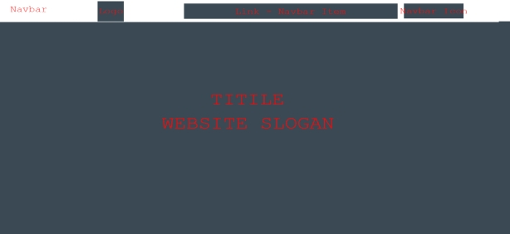

The site also has flexible support for mobile. In the mobile interface, the logo will still be displayed in the upper right corner. Along with that is a button with the hamburger menu icon. This button has the function of collapsing/expanding nav-items to make the website in moblie clearer.



### **Introduct Section**

This section will show the main title of the website as well as the working principle and short introduction

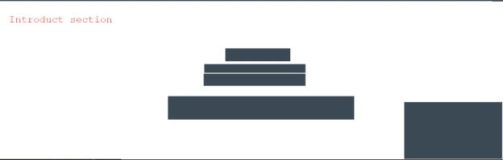

### **Featured advertising and services section**

This section will display our featured service and/or advertise third party services

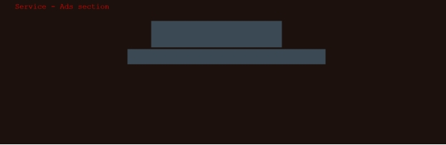

### **Short Gallery Section**

This will display an image gallery as a slider. These images are of the products that have been/are/will be auctioned by us.



### **Our Services**

In this section, the services provided by us or 3rd parties will be displayed. They are pictures/articles about the services provided.

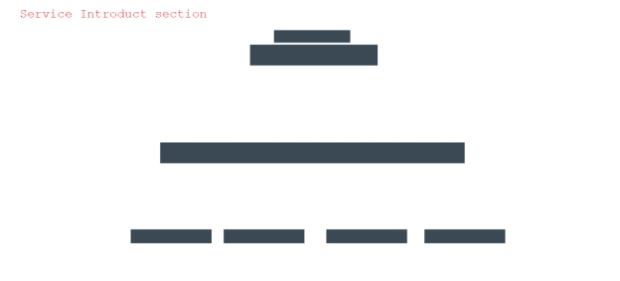

### **Testimonials Section**

The Testimonials section is where the testimonials of experts, customers and many antique collectors speak about us. Those are the evaluations of our quality, service and ability to work. Arguably this is our most proud area on this site.

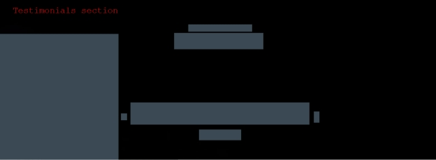

### **Team and Experts Section**

This section is where you will find our experts, professionals, as well as our proud collaborators. This place will tell you who you will work with if using our services!.



### **Contact Form Section**

Do you have antiques that need to be sold but don't know what to do? Or you simply want to use our antique valuation service. Or complain or contact for business cooperation? We welcome your much-awaited messages. Contact us through the form in this section!



### **Map and Footer Section**

We have our headquarters where we work and welcome valuable customers like you. For your convenience, this section will be an embedded map through the google map api.

And finally the footer section with our logo in the bottom left corner. In the middle are icons that link to our official social networking sites.

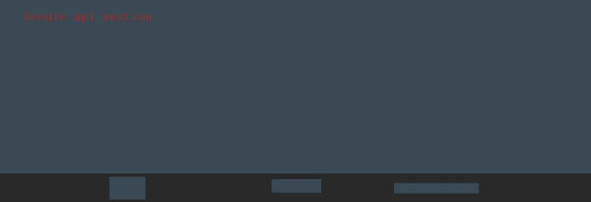

## **Screenshots**

### **Home pages**

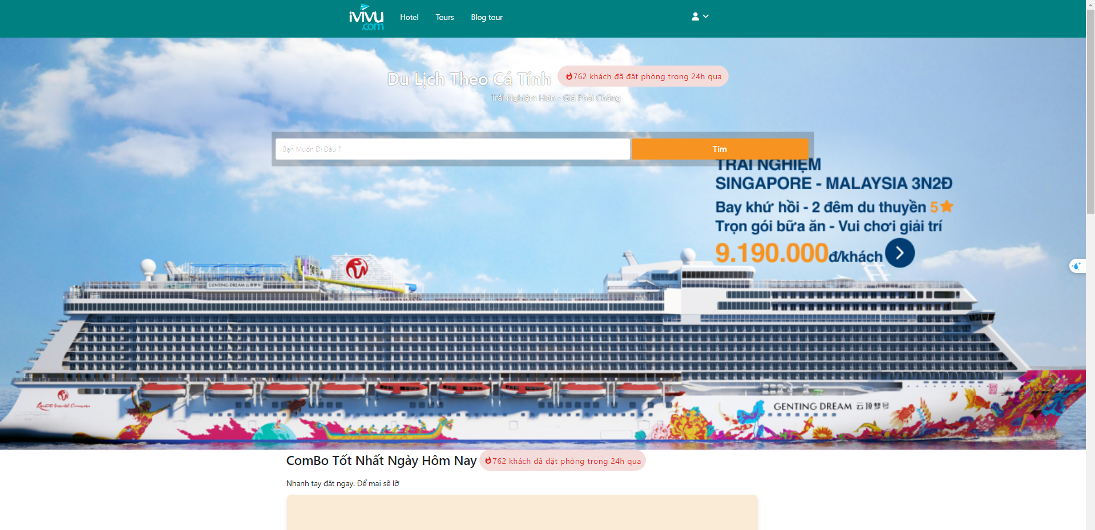

### **Introduct Section**

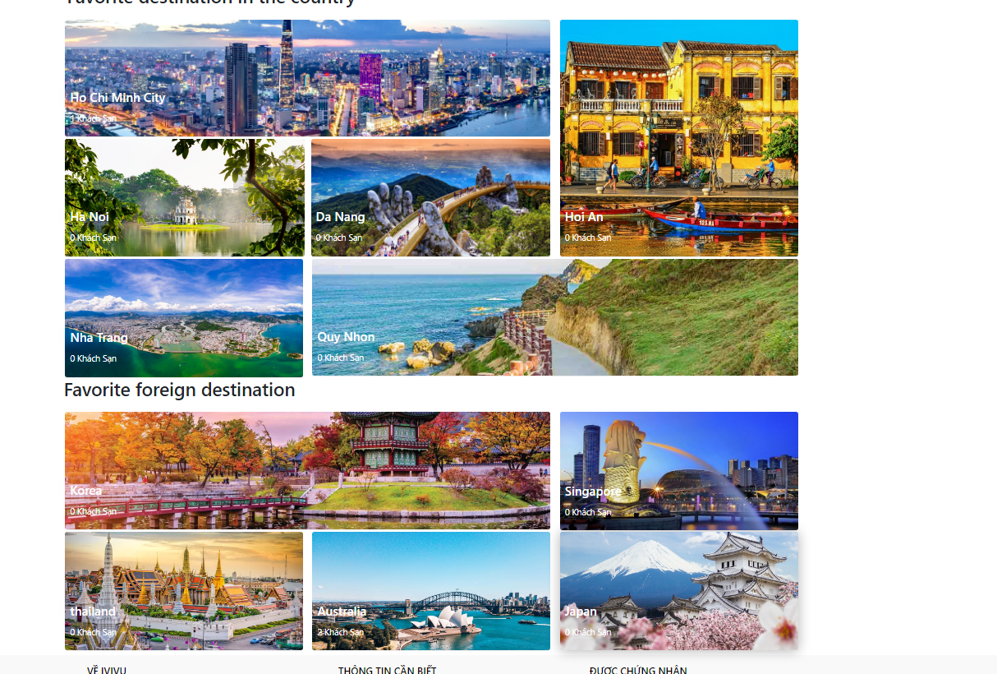

### **Tour**

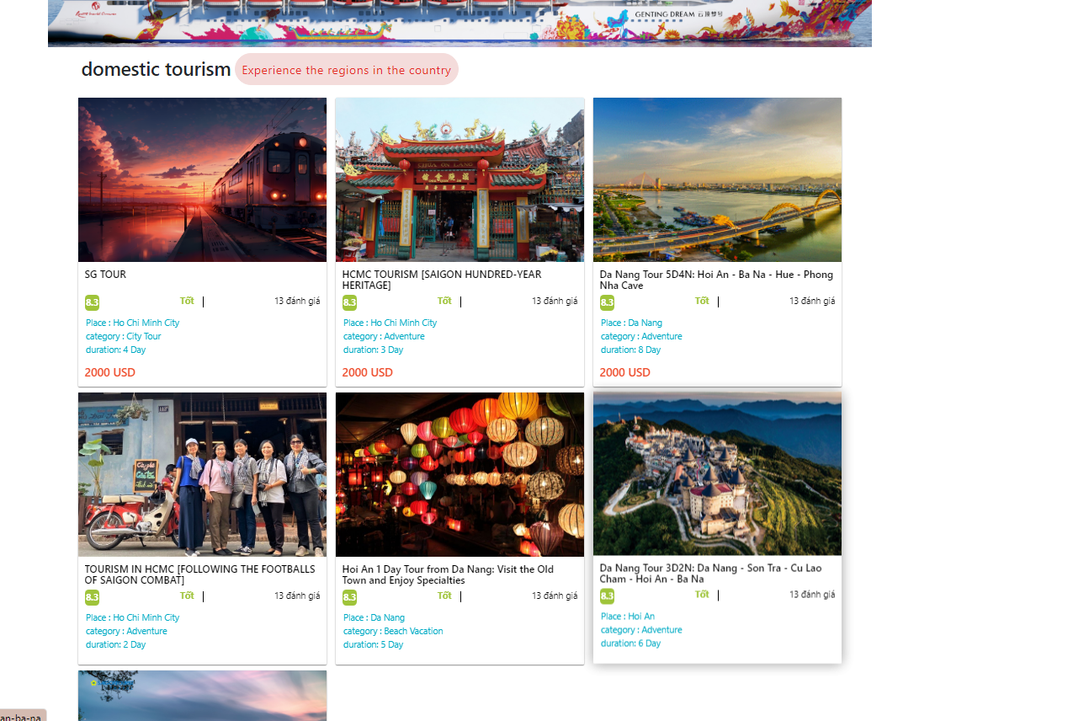

### **Tour details**

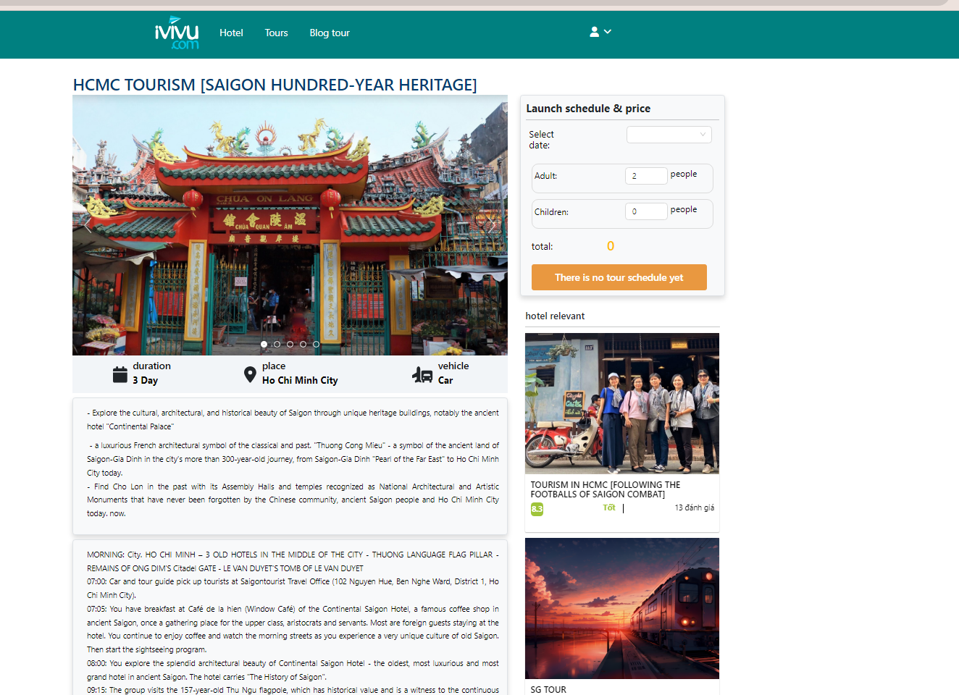

### **Cart**

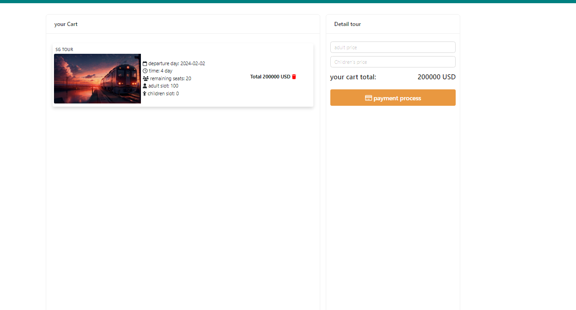

### **Profile**

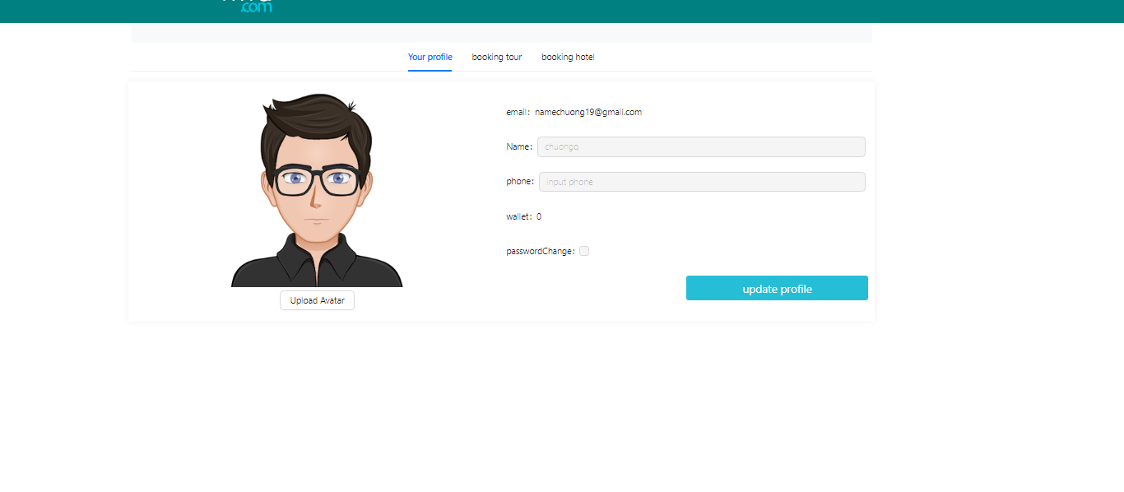

### **Blog Tours**

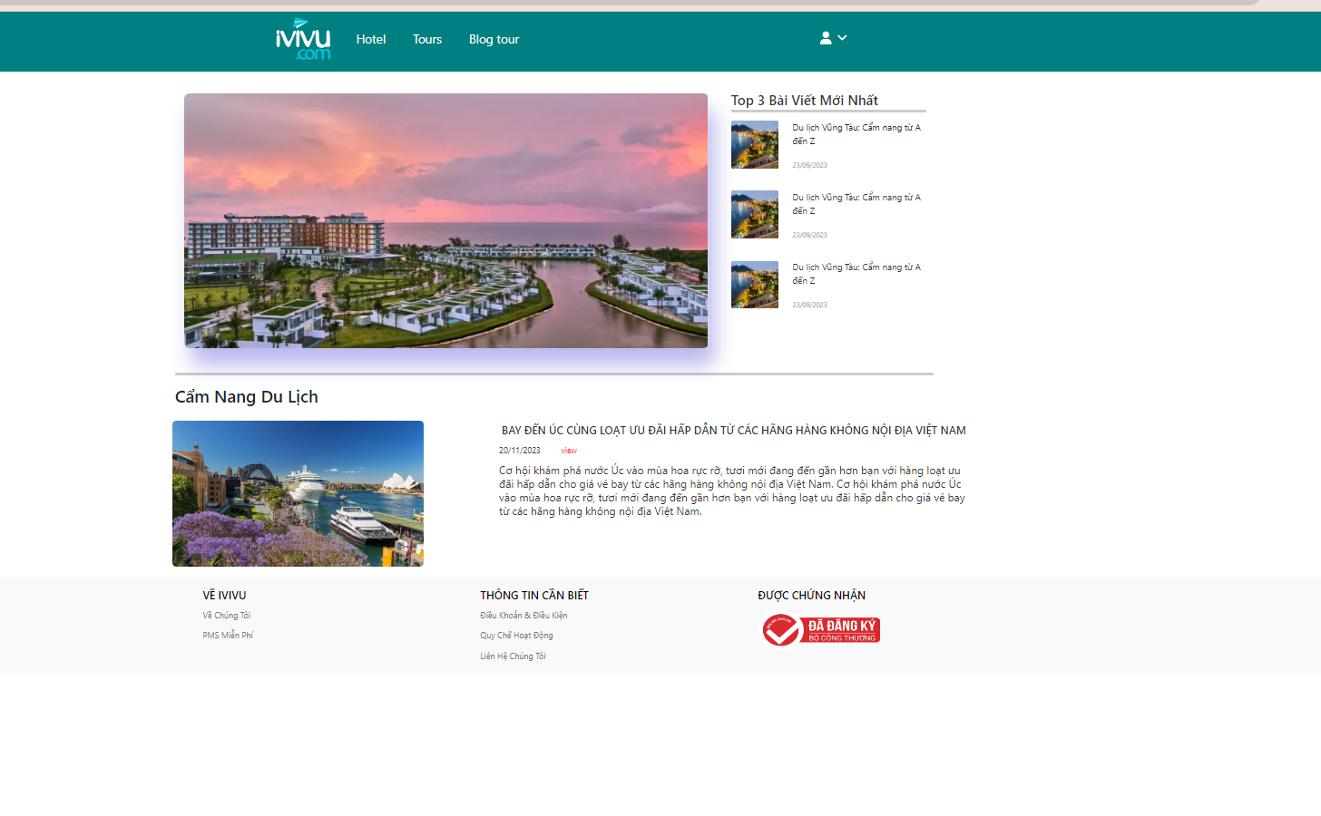

# REVIEW 3

## **TASK SHEET REVIEW 3**

|  |  |  |  |  |
| --- | --- | --- | --- | --- |
| **No** | **Page Name** | **Begin Date** | **TeamMate Name** | **Notes** |
| **Home Pages** | | | | |
| 01 | Navbar | 05/7/2023 | Le Thanh Thien  Quang Dai Vi |  |
| 02 | Home Title | Quang Dai Vi |  |
| 03 | Introduct | Nguyen Ngoc Thanh Chuong |  |
| 04 | Home page | Nguyen Ngoc Thanh Chuong |  |
| 05 | Tour Detail | Nguyen Ngoc Thanh Chuong |  |
| 06 | Cart | Quang Dai Vi |  |
| 07 | Profile | Quang Dai Vi |  |
| 08 | Blog Tour | Le Thanh Thien |  |
| 09 | Map Section |  | Le Thanh Thien |  |
| 10 | Footer Section | Le Thanh Thien |  |

|  |  |
| --- | --- |
| **Date:** | |
| Signature of Instructor:  **MS. LE MONG THUY** | Signature of Team Leader:  **Le Thanh Thien** |